Kodály Lesson
Pedagogical Sequence Outline
Yeji Yoon Musical Concept of Sixteenth Notes

Possible Musical Material for Concept:
“Old Brass Wagon” song

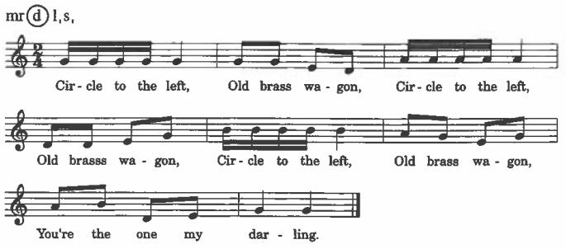

- Preparatory Activities:
  - Dancing “Old Brass Wagon”
    - The teacher will warm up by having students echo back two beat pattern composed of quarter note, eighth notes, and sixteenth notes on rhythm syllables.
    - The teacher will have students echo back the rhythm of “Old Brass Wagon” on rhythm syllables.
    - The teacher will add in the lyrics to the song.
    - Once the students are able to chant the song, I will have them stand up and for a single circle.
    - The teacher will teach the dance. After getting into a circle, everyone will hold hands. On verse one, they will circle to the left. On verse two, they will circle to the right. On verse three, they will circle around with their partner. On verse four, they will march in their place.
  - Singing “Old Brass Wagon”
    - The teacher will say the rhythm of old brass wagon on rhythm syllables and have students recognize the song.
    - The teacher will have students chant the whole song.
    - The teacher will teach the melody of the song by rote. Students will echo back the melody by phrase.
    - Once students know the song, they will dance to the song.
- Presentation Sequence”
  - Aural (Conceptual Awareness)
    - The teacher will chant the rhythm of the song and have students guess what song it is.
    - Then, the students will echo-chant the rhythm of the song “Old Brass Wagon” on rhythm syllables.
    - The students will sing the whole song once.
    - Then, students will dance to the song while singing with lyrics.
  - Visual (Iconic—Symbolic)
    - The students will echo-chant the rhythm of the song “Old Brass Wagon”.
    - The teacher will point to the rhythm on the board as he leads the class to echo-chant.
    - The teacher will point to the quarter note and ask what it is called. The students will be able to answer.
    - The teacher will point to the eighth note and ask what it is called. The students will be able to answer.
    - The teacher will point to the sixteenth note and ask what it is called. The students won’t know what it is called for they haven’t learned it yet. The teacher will tell them it is called sixteenth notes.
    - They will echo back the rhythm using quarter note, eighth note, and sixteenth note.
    - They will sing the song and clap only the sixteenth notes.
- Practice
  - Sight-reading
    - Teacher will have students echo back the rhythm using quarter note, eighth note, and sixteenth note on “ta”.
    - Teacher will ask students what we called each rhythm. (a quarter note, eighth note, sixteenth note).
    - Teacher will also ask students what the rhythmic syllables were for each rhythm.
    - Then, teacher will have couple echo-chant exercises on rhythmic syllables.
  - Improvisation of rhythm
    - The teacher will sing the “Old Brass Wagon” on la and have students guess what song it is.
    - Then, teacher will ask the students, “What different rhythms are in the song?”
    - The students will answer, “Quarter note, eighth note, and sixteenth note.”
    - The teacher will have students echo back rhythm while pointing to the corresponding flash cards that has rhythm on it.
    - The students will come up and make up four beat patterns to sight-read.

